R²GAMING
ADDICTION TO ACCOMPLISHMENT

BUSINESS PLAN
Date: 26th September 2025
COMPANY NAME: R SQUARE GAMING ORG.
CONTACT INFORMATION OF KEY PERSONAL ANUVIND K RAJ: anuvindkraj701@gmail.com
Mobile no: +91 89211 36287
[Founder, Owner]

TABLE OF CONTENTS

Heading | Page Number
Executive Summary | 3
Mission & Vision Statement | 5
Foreseeing Company History | 6
Business & Industry Profile | 9
Business Strategy | 16
Describing Product or Service | 22
Marketing Strategy | 24
Competitor Analysis | 26
Owners & Management Resumes | 27
Plan of Operation | 32
Projected Financial Statements | 33
Loan or investment Profile | 35
EXECUTIVE SUMMARY

Company Overview
The R square company is objected to be private Esports organization founded to support grass root level gamers in the growing gaming of India which supports for the growth of Gaming sector in India.
R square gaming is an Esports organization that aims to build, train and provide successful training for online gamers. This platform will help the very grassroot level players to accomplish the aim of being a professional gamer.

Market Overview
In the 21st century a lot different sectors are growing exponentially, one of the fastest growing sectors is the Esports sector which has a scope especially for the younger population around the world. There are lot of gaming markets growing around the world and one of the fastest growing gaming markets in Asia as well as in the world is Indian Gaming market
The India Esports Market is projected to grow from an estimated value of around $100 million in 2024 to several billion dollars by 2030-2031, with a strong Compound Annual Growth Rate (CAGR) of 15.7% to 28.4% between 2025 and 2030, according to various sources.

Product and Services
The R square gaming would conduct Esport tournaments across different locations which would provide an opportunity to the interested gamers especially players with weak financial and mental support especially from non- metro rural areas which comprises about 66% of gaming population in India.
The company would best gamers and professional train them to compete in the best Esports sector around the globalized economy in this technical world.
Customers
The company’s target customers would be youth population/ working population especially age group between 18-30. This is because India is having a demographic advantage of youth population. In the sector gaming a large proportion of gamers belongs to the age group of 18-30 years. The increasing number of gamers among the female population is promising for a possible growth in this sector. The female gamers comprise 44% gamers in India.
Finance and Managerial Aspect
The company would be under partnership. The managerial activities require more volunteers especially events.
For the development of a successful organization, it would require technical support like handling websites efficiently.
The firm would potentially outlook to raise financial support through sponsorship, tournaments, merchandise and investments from companies
The expenses that the firm could incur would be possibly from cash prices, training the gamers, marketing & advertising, wages, interest. The raised capital would be used for the future growth and expansion of the company.

MISSION AND VISION STATEMENT
Mission
The Mission of the $R^{2}$Gaming is to build a world class Esports organization that empowers the gamers of the rural non metro areas, empower players, creates opportunities across gaming, content and competition. We strive to provide high quality experiences for audiences while consolidating professional and aspiring gamers with resources they need to grow and succeed

Vision statement
The mission of the $R^{2}$ Gaming is to become a global leader in Esports and gaming entertainment -- a global brand recognized not only for competitive excellence, but also for inspiring next generation gamers and shaping the future of gaming sector in India.

As an outcome of the success of this company
- Creates a new career path for the youth and creates new employment opportunities apart from the blue collared, white collared jobs etc…
- Improves the industry growth and leads to innovation in broadcasting, live events, digital platforms, and fan experiences
- Normalises Esports as a common competitive sport alongside traditional sports and connects people across different cultures and countries
- Attracts international partnerships and sponsorships, bringing global recognition and investment opportunities to the region.
- Creates ancillary industries such as esports journalism, game analysis, merchandise design, and influencer management, further broadening economic impact.
- Strengthens the national brand image by positioning the country as a hub for innovation, youth culture, and digital entertainment.
- Encourages academic and institutional involvement with universities and training centres offering esports courses, certifications, and research opportunities.

FORESEEING COMPANY HISTORY

$R^{2}$ established in 2025 with the vision of creating a next-generation esports organization that empowers youth, builds strong gaming communities, and competes at the highest levels of play. While newly founded, the company is built on a passion for developing the gaming industry, digital culture, and the belief that esports can inspire, educate, and connect people worldwide. The very same time it can provide and arena to earn for the youth who are passionate about gaming and giving them the opportunities to follow the dream they are passionate about rather than sticking into the vicious cycle of conventional job cycle

Although the journey is just a beginning, we’ve provided the map of the clear trajectory of milestones that shape the organization’s history in the years ahead
Year 1-3
In the first 3 year, the organization will officially launch as a startup esports organization focused on competitive excellence and community engagement. The first roster of talented players will be recruited and trained, establishing a professional foundation for competition. Online tournaments and friendly matches will be hosted to begin building a fanbase and creating initial engagement with the esports community. Simultaneously, the organization will start developing its social media and streaming channels to showcase content, attract early sponsors, and raise brand awareness. Friendly tournaments with attractive cash prizes would magnetize the gamers to engage this would increase the brand oriented fanbase and would help me pool capital for the upcoming years for the expansion of the company. The initial years should help the company to capture local support and local gaming market

Year 3-6
By next 3 years, the organization plans to expand into additional game titles to reach a wider audience and diversify competitive opportunities and experience. Initial sponsorships and partnerships with gaming brands, lifestyle companies, and tech innovators will be secured to provide financial support and marketing leverage with aim of expanding it. The competitive team will participate in regional tournaments to gain recognition and valuable experience in high-stakes competitions. Fan engagement will continue to grow through consistent content creation, live streams/ broadcasting, and interactive community events. Efforts will be made to strengthen the organization’s presence on emerging platforms and social media networks. These initiatives will solidify the brand’s reputation as a serious competitor while laying the foundation for long-term partnerships and business development.
By the end of the second half of the first 2 years the company should be able to able to capture the gaming market and should act as a leading Esport organization of the Southern part of the country

Year 6-9
The subsequent years, the organization will launch a youth development program and training academy designed to identify and nurture emerging talent. This initiative will provide aspiring players with coaching, mentorship, and competitive experience, expensive and professional training to cope up with the increasing competition in the gaming field creating a clear pathway to professional esports careers. Hybrid offline and online events will be organized to engage fans and provide live experiences for the community. Merchandise and lifestyle branding will be introduced to create additional revenue streams and deepen brand loyalty. Content production will expand to include tutorials, behind-the-scenes footage, and interactive fan experiences. These efforts will position the organization as both a competitive force and a community-centered brand, enhancing its long-term visibility and influence.
Year 9- 12
By the 9th year to 12th year of the company’s establishment, the organization will actively compete in international tournaments, showcasing its growth and professionalism on a global stage. Strategic partnerships with major sponsors and international brands will expand the organization’s reach and financial stability. The fanbase will continue to grow as engaging content, streaming, and live events attract audiences worldwide. Marketing efforts will focus on cross-platform engagement, collaborations with influencers, and interactive campaigns to strengthen fan loyalty. The organization will continue refining its internal operations, player development, and content production to ensure consistency and quality. These initiatives will solidify the brand’s reputation as a globally recognized esports organization with both competitive and community impact. By this development it would capture and improve the gaming sector of the country and would be recognized by the society as well.
Like it captured the southern part of the country by the end of the second half of the 4th year the company should capture Indian gaming market entirely and should be the leading esport organization from the country

Year 12-15
From the 12th to the 15th year, the organization will position itself as a globally recognized esports brand, balancing competitive success, youth development, and entertainment. Revenue streams from sponsorships, merchandise, and digital content will provide long-term financial sustainability. Advanced fan engagement platforms, including interactive streaming and digital events, will deepen connections with supporters worldwide. The youth academy and training programs will have produced several competitive players entering professional circuits. Strategic partnerships with major brands and media organizations will enhance visibility and influence in the esports ecosystem. By the end of this milestone, the $R^{2}$ will be seen as a respected, innovative, and community-focused global esports organization. A recognized Esport organization from India, the growing Asian Giant to compete against other international Esport teams in the world
An overview

The esports industry is experiencing rapid global growth, with increasing opportunities in competitive gaming, streaming, content creation, and youth engagement. As the company develops, the organization aims to leverage this growth by establishing itself as a competitive and innovative brand that resonates with players, fans, and sponsors worldwide. In the coming years, the organization expects to expand its roster across multiple popular game titles, develop talent through structured youth programs, and create immersive fan experiences through digital platforms and live events. Strategic partnerships with global brands and media companies will provide sustainable revenue streams and enhance visibility in both regional and international markets. The generated revenue will be used for developing more and more gamers to be engaged

Beyond competitive success, Organization plans to have a significant social impact by empowering young gamers, promoting inclusivity, and fostering communities that combine education, entertainment, and professional development. By investing in content creation, fan engagement, and community initiatives, the organization will position itself as a leader in both esports and digital entertainment. Overall, the future outlook envisions company growing into a globally recognized brand, balancing competitive excellence, business sustainability, and positive societal impact in the rapidly evolving esports ecosystem. The brand royalty of the company should touch the sky and brand itself should attract investors.

BUSINESS AND INDUSTRY PROFILE

The global esports industry has witnessed explosive growth, transforming from a niche hobby or which was earlier considered to be addictive recreational activity which later entered into a mainstream digital entertainment sector. In 2025, the industry is projected to generate around $1.79 billion in revenue, driven primarily by sponsorships, media rights, merchandise, and streaming revenue. Revenue growth has been collected from the different devices like pc’s, mobiles and particularly strong in mobile gaming, reflecting the increasing accessibility of esports across devices. Demographically, esports audiences are predominantly young, with over 70% under the age of 35, mainly from the age group between 18-30 and a growing balance between male and female viewers where about 48% of the gamers around the globe are female gamers. Usage trends indicate that viewers increasingly prefer on-demand streaming and highlights rather than full live broadcasts, while social media platforms are becoming a major channel for esports engagement.
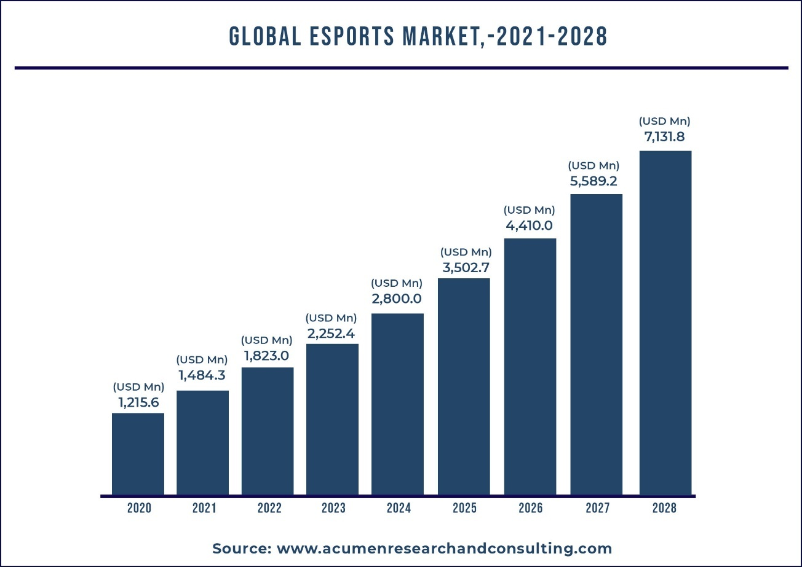
The above mentioned chart represents estimated revenue of esport sector from the near future

Location-based trends highlight significant regional differences in esports adoption and growth. Asia, particularly China, South Korea, and Japan, leads in both revenue and player base, supported by strong government and corporate investment in infrastructure and tournaments. North America follows closely, driven by a robust professional league system, high sponsorship activity, and media rights deals. Europe has seen rapid growth in competitive leagues and esports viewership, especially in countries like Germany, France, and the Nordic nations. Emerging markets in Latin America, the Middle East, and India are showing increasing engagement, fueled by mobile gaming, internet penetration, and rising youth interest in esports competitions.
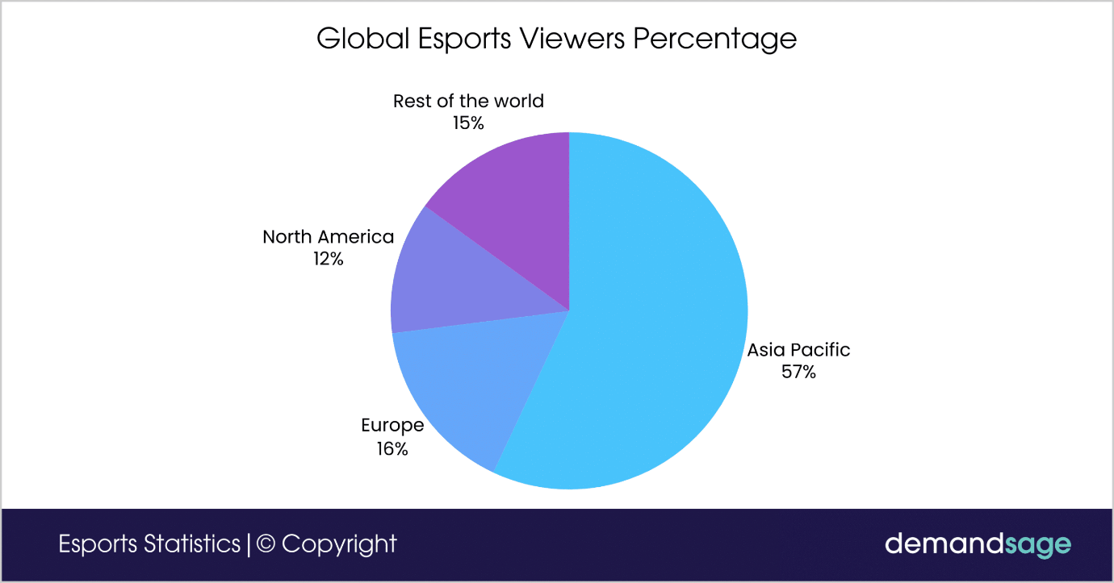
The above pie chart gives the global esports views percentage by different location.

Technological adoption is reshaping how esports is consumed and monetized. Platforms like Twitch, YouTube Gaming, and Kick are dominating streaming platforms to be noticed, while mobile-first apps and social media integrations are expanding audience reach. Revenue trends show a shift toward digital monetization, including microtransactions, in-game advertising, and esports betting, complementing traditional sponsorship and media deals from the early trend of liquid transaction. Demographic trends also reveal an increase in the participation by women and casual gamers, broadening the market beyond hardcore esports fans. The integration of emerging technologies such as AR/VR, AI-driven analytics, and interactive live streaming is enhancing engagement and creating new revenue streams, live streaming also acts as platform for fan interaction and growth of the professional gamer, positioning esports for continued global expansion over the next decade.

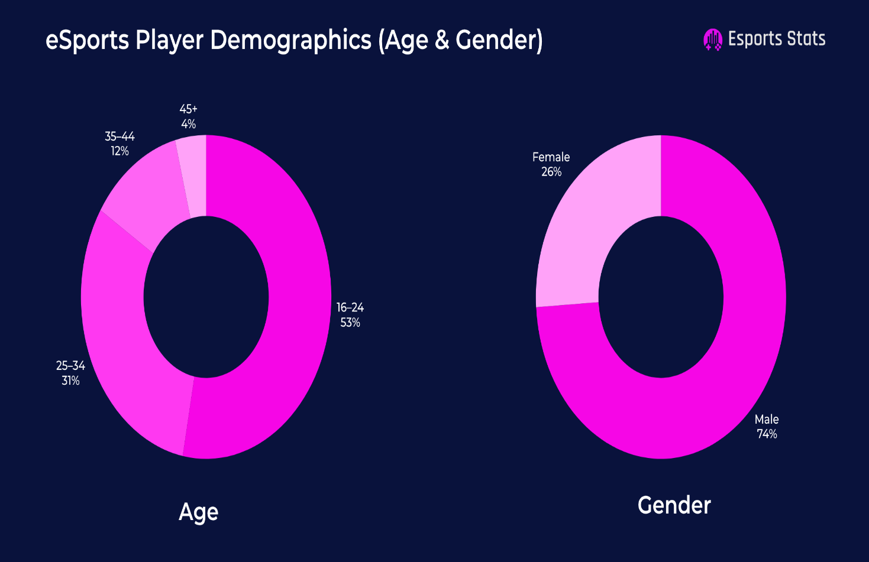
The above provided pie chart mentions the demographic structure of esport sector
ENTRY AND EXIT BARRIES IN THE SECTOR
Entering the Esports market presents several challengers for the company especially new startups High initial costs, including player recruitment, training facilities, equipment, and marketing, can be significant obstacles for the organization. Additionally, the industry is highly competitive with established organisations leading the tournaments sponsorships, and fan followings, making it difficult for newcomers to gain recognition. Building credibility and attracting sponsorships requires strong branding, consistent performance, and active community engagement, which can take more years to achieve. Regulatory and contractual considerations, such as player contracts, broadcasting rights, and regional esports regulations, can also complicate market entry.
Exiting the Esports market can be equally complex due to the intangible nature of brand value, player contracts, and ongoing partnerships. Organizations often invest heavily in digital infrastructure, content production, and fan engagement, which may not be easily liquidated so exiting requires several other financial assistances. Breaking long-term sponsorship or partnership agreements can result in financial penalties or reputational damage. Furthermore, the esports market is rapidly evolving, so even organizations seeking to pivot or exit may find their assets — including player talent, brand recognition, and fanbase — difficult to transfer or sell. As a result, both entry and exit require careful strategic planning and resource management to minimize risks.

Revenue Trends
The global esports industry has diversified its revenue streams, with sponsorships emerging as the dominant source. In 2025, sponsorships are projected to contribute approximately $1.2 billion, accounting for about 25% of the total esports’ revenue. This is followed by media rights, which are expected to generate around $1 billion representing 21% of the market. Other significant revenue sources include merchandise and tickets ($800 million, 17%) publisher fees ($600 million, 13%), digital revenues ($500million,10%) and streaming ($400million, 8%)
Looking ahead, the global esports market is projected to reach $4.8 billion in 2025, with a compound annual growth rate (CAGR) of 5.56% from 2025 to 2029.
This growth trajectory is fueled by increased sponsorships, media rights deals, and betting revenues. The expansion of franchise leagues, especially in games like League of Legends, Call of Duty, and Valorant, will also stabilize revenue streams through long-term contracts and media deals.

By 2035, the Esports market is expected to grow to $25.4 billion, representing a significant increase from current levels. This growth is driven by the increasing popularity of mobile esports, the expansion of esports infrastructure in emerging markets, and the integration of new technologies that enhance the gaming experience.
Regional dynamics play a crucial role in shaping the global esports revenue landscape. In 2025, North America is projected to lead the market with revenues of approximately $1.2 billion, driven by a strong presence of esports organizations, media rights deals, and sponsorships. Asia, particularly China and South Korea, follows closely, with revenues of $1 billion and $800 million, respectively. These regions benefit from a large player base, government support, and established esports ecosystems.

Europe is also experiencing growth, with revenues expected to reach $600 million in 2025. Emerging markets in Latin America and the Middle East are showing increasing engagement, fueled by mobile gaming, internet penetration, and rising youth interest in esports competitions. These regions are expected to contribute significantly to the global Esports revenue in the coming years.
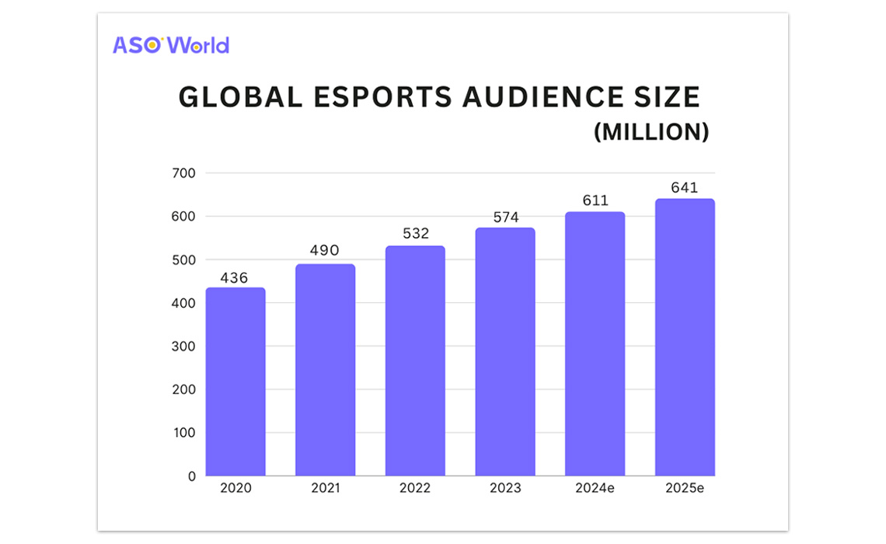
Gaming Sector in India
India's gaming industry has experienced remarkable growth in recent years. In 2024, the market was valued at approximately $4.3 billion, with projections indicating it could reach $15.2 billion by 2033, reflecting a compound annual growth rate (CAGR) of 15.2% . This expansion is driven by factors such as increased smartphone penetration, affordable internet access, and a burgeoning middle class.
The country boasts a substantial gaming community, with over 591 million active gamers in 2024, each dedicating an average of 13 hours per week to gaming. Mobile gaming dominates the landscape, comprising nearly 90% of the total gamer base . The demographic profile is diverse, with a significant portion of gamers aged between 15 and 24 years, and a notable increase in female participation
The Indian gaming sector's revenue composition has evolved, especially following regulatory changes. In 2024, the market generated approximately $943 million, with projections to surpass $1 billion in 2025. In-app purchases remain the dominant revenue model, accounting for over 41% of the market share, while subscription-based models are experiencing rapid growth
Recent legislative actions have significantly impacted the sector. In 2025, the Indian government enacted a ban on real-money gaming (RMG), citing concerns over addiction and financial harm. This move led to the cessation of operations by major players like Flutter's Junglee and MPL, affecting over 1,000 jobs . In response, companies are pivoting towards alternative monetization strategies, such as advertising and sponsorships, to sustain their operations.
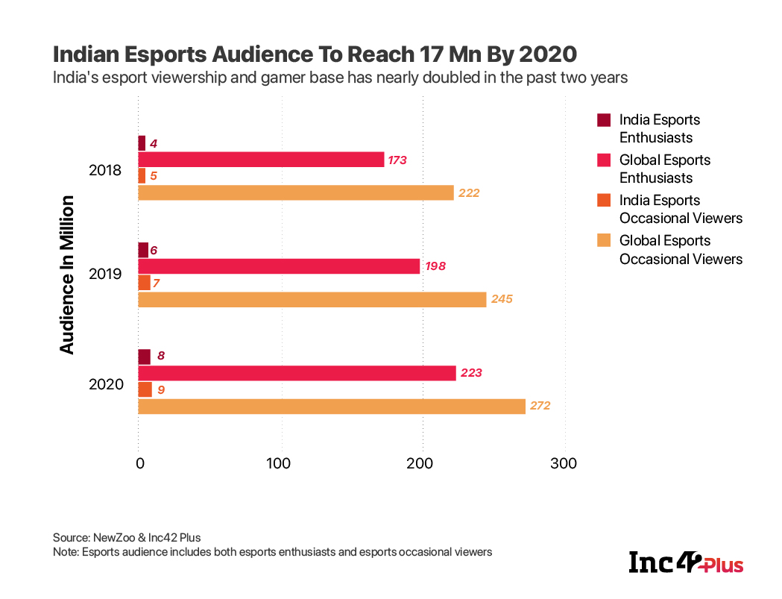

STAGE OF GROWTH
Start-up Stage:
In the start-up phase, our eSports organization will focus on establishing a competitive team and building a strong brand identity. Initial efforts will center on participating in tournaments, creating engaging online content, and cultivating an early fanbase. We will also explore small-scale sponsorships and merchandising to generate our first revenue streams while laying the foundation for long-term growth.
Growth Stage:
During the growth phase, the organization will expand its roster and increase participation in national and international tournaments. Revenue streams such as merchandising, streaming, and sponsorships will scale alongside our growing fanbase, reflecting the organization’s rising market presence. Strategic investments in team development, content creation, and brand partnerships will ensure continued competitive performance and sustainable growth.
Maturity Stage:
At maturity, the organization will be a recognized player in the eSports ecosystem with multiple diversified revenue streams. Focus will shift to maintaining competitive excellence, expanding into additional games or leagues, and leveraging partnerships and media opportunities. Strong fan engagement and optimized operations will ensure long-term sustainability, brand longevity, and continued success in a competitive market.

BUSINESS STRATEGY

Desired Image and position in the market
The $R^{2}$ Gaming aims to be recognized as a professional, youth driven, and community- focused esports organization. The brand will be positioned as both a competitive powerhouse and a platform that nurtures emerging talent in the esports sector. Unlike many organizations that focuses mainly on winning tournaments, this brand will balance performance with content creation, inclusivity and grassroots development. The desired image is one of the authenticity, innovation, and leadership in the evolving esports landscape. Aims at being India’s most successful Esports organization in history, revolutionizing the Esports platform in the Indian gaming market and as well as a successful Esports organization in the world. The company aims to be recognized as a firm which develops grass root level rural gamers to a professional gamer in the country.
COMPANY GOALS AND OBJECTIVES
Operational
Starts with organizing tournaments locally, then expand the tournament scope which will help to filter out the emerging talents to be trained professionally with expensive coaches and training.
Recruit and train competitive teams across multiple esports titles initially beginning with single title and eventually expanding to multiple streams.
There is a huge bridge between gamers in rural and metropolitan cities, youngsters in rural regions are lacking the opportunities to develop their gaming skills. Once the company reaches the potential it will eventually develop a youth academy and training programs to nurture future talent. This will help the new generation to consider the gaming platform as a career opportunity and at the same time will help the company to gain popularity among the gaming population.
Digital support is significant for company’s growth in the Esport sector. A digital infrastructure for streaming, content production and fan engagement will be then developed. Fan engagement and streaming is another method of gaining support and popularity for the company. As the popularity of the company increases significantly it would attract investments and sponsorships from well established companies.
Financial strategy
Our Esports organisation seeks to raise seed funding through angel investors, gaming enthusiasts, startup funds, and high-net-worth individuals (HNIs) who believe in the exponential growth of the gaming industry after reaching its potential growth of 5 years after the establishment.
Organising tournaments and attractive cash prizes magnetize amateurs as well as professional gamers to participate. As the number of tournaments increases, with enough digital advertising via social media would elevate the brand image widely. Here I have provided a chart of revenue that could generated by organizing a single game and multiple tournaments.
🎮 Tournament Revenue Model Example (PUBG Mobile)
Entry fee: ₹500 per team
Max teams per tournament: 24 teams (₹500 × 50 = ₹25,000 collected)
Prize Pool: ₹12,000 (distributed as: 1st ₹7,000 | 2nd ₹3,000 | 3rd ₹2,000)
Organizer’s Profit per Tournament: ₹13,000

Tournaments per Month Monthly Revenue (Profit) Annual Revenue (Profit)
4 Tournaments (Weekly) ₹52,000 ₹6,24,000
8 Tournaments (Bi-weekly) ₹1,04,000 ₹12,48,000
12 Tournaments (3 per week) ₹1,56,000 ₹18,72,000
20 Tournaments (Heavy schedule) ₹2,60,000 ₹31,20,000

Even with 4 tournaments a month, we cross ₹6+ Lakhs per year in profits. Scaling to 8–12 tournaments monthly make ₹12–18 Lakh annual profit business, without factoring extra revenue like sponsorships, ads, or merch. Heavy scaling (20+ tournaments a month) can cross ₹30 Lakhs annually, but requires bigger staff, casters, and operational setup.
This estimated revenue scale is purely tournament based.

ESTIMATED STREAMING REVENUE IN DIFFERENT PLATFORMS

Platform / Monetization Type | Estimated Revenue per 1,000 Monetized Views / Impressions | Comments / Conditions
YouTube Gaming / General Content | ~ ₹20 to ₹100 per 1,000 views (RPM) | Lower end if audience mostly India + general gaming / entertainment content; higher toward ₹80-₹100 if audience is global / ad demand is strong
YouTube — High Value Niches (Tech / Reviews etc.) | ₹75-₹300 per 1,000 views in special high-CPM categories. | If gaming org also produces content in tech, reviews, or high advertiser demand topics, RPM can go up.
YouTube — Lower-Demand / Regional / Ad Fill Poor | ₹20-₹40 or even lower (monetized views only) | Many views may not be monetized (no ad shown, non-premium views) → effective RPM lower.
Twitch (India / Viewers Mostly India) | Approx $1.00 to $3.25 USD per 1,000 ad impressions → converting ~ ₹90-₹270 depending on rate, platform cut, viewer country. | Ad revenue alone; Twitch also has subscriptions, bits, donations, etc. Also dependent on how many viewers are in regions with good ad budgets.
Kick (Subscriptions Revenue Share) | The revenue split is very favorable (95/5) for subscription revenue. But per-view ad-based revenue numbers aren’t publicly well documented for India. | If you can build subscribers on Kick, you keep ~95% of that revenue; so subscription income per subscriber can be strong. But depends on having paying viewers.

SWOT Analysis
Strength
- Growing Industry appeal- Esports is one of the fastest growing entertainment sectors in the world with increasing mainstream acceptance It is projected to keep expanding as streaming platforms and online communities grow larger every year. Traditional sports teams and investors are also showing interest, which validates the industry’s credibility. This makes it easier for startups to attract attention from sponsors, fans, and media outlets
- Demographic advantage: Esports have a stronger appeal to youth population whi are highly engaged digitally. Youth population spend significant time on game related content. Since India is having the advantage of demographic dividend it is a huge advantage for the gaming sector as most of the gamers are between the age group of 18-35
- Low entry barriers- Esport sector is comparatively having less entry barriers compared to traditional sporting sector. This platform does not require expensive stadiums or physical infrastructure to begin with . A startup can initially operate online with small budget, making it more accessible for entrepreneurs. Over the time the organization can grow steadily by investing earnings into facilities, teams and branding.
- Flexibility- Small startups can easily adapt faster to new games, trends and platforms compared to established org.. This agility allows them to experiment with different strategies without heavy bureaucracy. We can switch focus to emerging titles or popular formats more easily. Being early adopters of trends also helps capture niche audiences before competitors enter.

Weakness
- High competition – Established organization dominate in sponsorships, deals and player recruitment. Since they’ve more capital compared to startups they would attract better sponsorships and investments
- Brand recognition – High established organization have higher brand recognition which makes startups to face difficulty of standing in the market.
- Limited capital – Salaries, tournament fees, marketing, maintaining player contract requires strong investment and it acts as a barrier for the startups with limited capital Monetization are still evolving and requires much time to stabilize

Opportunities
- Digital era- most of the growing economics are highly shifting to digitalizing their economy. Especially countries like India have shifted almost completely to digital economy this would ignite the growth of the gaming sector in the near future
- Local and Regional Leagues- Smaller grassroots tournaments and local leagues often receive less attention from large esports organisations, creating space for startups. By dominating local markets, startups can establish credibility and build strong fan bases. Local partnerships with schools, universtities and businesses can strengthen financial sustainability. Once established these grassroots successes can serve as stepping stones to larger national or international competitions
- Educational programs- Many schools and universities are exploring Esports clubs, scholarships, and training programs Startups can collaborate with these institutions to build academics , workshops, or youth leagues new talent piplelines. Positioning as an educator also enhances credibility and brand trust

Threats
- Market Saturation- With many Esports organisation forming worldwide, the industry risks becoming overcrowded . This makes it harder for startups to differentiate themselves or secure meaningful sponsorships. Fans may also become overwhelmed by too many teams, causing weaker brands to fade. Without strong branding and a unique proposition, a startup could quickly get lost in the noise.
- Publisher Power- Esports organisations are heavily dependent on game publishers who control league structures, rules and intellectual property. If a publisher decides to shut down a competitive scene or impose restrictive participation rules, startups can lose their primary revenue stream overnight. This dependency reduces organizational independence. Building resilience requires diversifying across multiple games , which is often difficult for new entrants.
- Uncertain Profitability- Even large Esports organisations have struggled to generate consistent profits. This creates hesitation among investors, making fundraising harder for startups. Reliance on volatile sponsorship deals makes financial stability unpredictable. Without diversified income streams, a small downturn could endanger the entire organization.
- Player Burnout- Esports careers are notoriously short due to the intense demands of competition and training. Burnout, health issues, or early retirements can destabilize a roster. For a startup, losing a star player can also mean losing it’s fan base and sponsors. Ensuring proper player care is expensive, which may be unsustainable at the early stage
- Economic Downturn- in times of recession, marketing and sponsorship budgets are often the first to be cut. Since most Esports organisations rely on these deals, downturns can have a direct impact on revenue. Fans may also spend less on merchandise or event tickets, reducing income streams further. This external threat makes startups particularly vulnerable due to their lack of financial reserves.
Competitive strategy
Cost leadership
Our organization will leverage cost efficiency to make Esports accessible in regions where resources are limited. By organizing local tournaments at community centers, schools, and low-cost venues, we reduce operational expenses while maximizing participation. Utilizing digital platforms for registrations, live streaming, and promotions further minimizes marketing costs. Over time, economies of scale will allow us to negotiate better deals with sponsors, equipment providers, and internet service partners. This strategy ensures affordable participation fees, making our tournaments and training programs more inclusive to
grassroots talent.
Differentiation
We will stand out by offering opportunities that go beyond competition, focusing on talent development and rural empowerment. Unlike many Esports organizations that primarily recruit already established players, our model nurtures gamers from underserved areas through structured training programs, mentorship, and exposure to professional environments. By emphasizing community-driven tournaments, local culture, and unique storytelling, we create an emotional bond with fans and sponsors. Additionally, our strong presence in rural areas sets us apart, as we position ourselves not just as a gaming organization but as a movement that transforms Esports into a career path for untapped talent.
Focus
Our initial focus will be on grassroots gamers in rural and semi-urban communities. These regions are largely ignored by major Esports organizations but hold a huge pool of undiscovered talent and highly engaged audiences. By tailoring tournaments, training programs, and outreach specifically to this niche, we create a loyal base of players and fans. Over time, this focus allows us to dominate a unique market segment before expanding nationally and internationally. This concentrated strategy ensures we build credibility, loyalty, and expertise in developing players from the ground up. The focus groups will be the youth population especially gamers within the age group of 18-30 whom are willing to differentiate themselves from the traditional job sector and are willing to explore the sector they are passionate about.

DESCRIBING PRODUCT OR SERVICE
Product or service Features
Our organization will provide a platform for gamers by organizing local Esports tournaments in rural and semi-urban regions. These tournaments will serve as both competitive events and scouting grounds for identifying talent. The tournaments would also help to pool financial assistance for expanding the organisation. Beyond tournaments, we will offer structured training programs, bootcamps, and mentorship for grassroots players, equipping them with the skills to compete at higher levels. Over time, we will expand into team management, content creation, and merchandise sales as the brand grows.
Customer Benefits
Players benefit from exposure, structured training, and access to professional opportunities that were previously unavailable in underserved areas. Sponsors and partners gain access to an untapped audience, primarily rural youth and gaming enthusiasts, allowing them to connect with new markets. Fans enjoy affordable, localized Esports entertainment and the ability to support homegrown talent. Communities benefit from job creation, digital literacy improvement, and youth empowerment through Esports. It would also help the upcoming gamers to dream something more than just an addictive mobile gaming for recreational activity.
Warranties and Guaranties
We will guarantee fair tournament operations by ensuring transparent rules, anti-cheat systems, and professional event management. Players in our training programs will be assured access to certified coaches, structured schedules, financial as well as emotional support and opportunities to showcase their progress. For sponsors, we provide measurable engagement metrics such as audience reach, impressions, and participation levels. These assurances build trust with players, fans, and partners. This will assure the growth of the company in the sector
Unique Selling Purposes (USP)
Our USP lies in empowering rural and grassroots gamers who are often overlooked by mainstream Esports organizations. By focusing on underserved regions, we tap into a vast pool of undiscovered talent and build loyalty from the ground up. Unlike competitors who primarily recruit elite players, we invest in development pathways, transforming casual gamers into professionals. This creates not just a team, but a movement that represents inclusivity, community, and opportunity in Esports. A hope for the youngsters in the competitive economy.
Trademark protection
We are outlooking to trademark our organisation’s name, logo, and brand identity to protect it from the imitation as the business grows. Intellectual property rights will be applied to unique tournament formats, training structure, and branded merchandise. Protecting these assets ensures brand recognition and secures long term value.

Production Process
Raw Materials
The primary resources include gaming equipment (PCs, consoles, peripherals), reliable internet connectivity, venue space for tournaments, and software for streaming and broadcasting. For training, we require digital tools such as coaching platforms, analytics software, and learning materials. Merchandise production will involve apparel, accessories, and Esports gear. Other resources include secured websites and protection of the data.

Costs
Major costs include event setup (venue rental, equipment), player development (coaches, trainers, infrastructure), and marketing (social media, streaming platforms). Additional expenses involve staffing, logistics, sponsorship activation, and online broadcasting tools. Over time, revenue from sponsors, merchandise, and ticketing will balance these operational costs.
Key suppliers
Suppliers will include gaming hardware brands, internet service providers, software developers, and event vendors. We will also partner with local educational institutions and community centers to access affordable venues. Apparel manufacturers will serve as key suppliers for merchandise production.
Leading times
Organising local tournaments will typically require 2-3 months of preparation including sponsorship acquisition, promotion and logistics (if the company is going for external support). Training programs will run in structured seasonal cycles (3–6 months), allowing players to progress step by step. Merchandise production and delivery will operate on a rolling basis, with 2–4 weeks lead time depending on supplier contracts.
Future product or service offering
In the future, the organization will expand into professional Esports teams that compete in national and international tournaments. We will also build a digital platform or mobile app that allows fans to track tournaments, watch streams, and connect with their favorite players. Additional revenue streams will include exclusive digital content, brand collaborations, gaming academies, and large-scale franchise tournaments. As the brand grows, we aim to position ourselves as a global Esports ecosystem originating from grassroots development.

MARKETING STRATEGY
Problem to be solved or benefit to be offered
Many talented gamers in rural and semi-urban areas lack access to tournaments, training, and exposure. Our organization solves this by providing affordable local tournaments, structured coaching, and clear career pathways in Esports. The benefit offered is accessibility, opportunity, and empowerment, allowing underrepresented players to enter the competitive gaming industry. This could be considered as both the problem to be addressed and the benefit the organization is providing.
Demographic Profile
The primary demographic for our Esports organization consists of young individuals aged 15–30, as this group makes up the majority of both competitive players and dedicated fans. Globally, most professional Esports players fall between 16–28 years old, with competitive performance peaking in the late teens to mid-20s, while those above 30 often transition into coaching, content creation, or management roles. In terms of viewership, more than 70% of global Esports fans are aged 16–34, and India reflects a similar trend, with the majority of its gaming audience concentrated in the 15–29 age bracket. India’s youthful population offers a unique advantage, with over 65% of citizens under the age of 35 and more than 50% under 25, making the country one of the youngest markets in the world.

Gender distribution in Esports currently skews male, with around 70–75% of professional players worldwide being men, but female participation is steadily rising, especially in casual gaming and streaming communities. In India, women account for about 17–20% of the gaming population, particularly in mobile gaming, which presents an emerging opportunity for inclusivity and sponsorship appeal. Rural and semi-urban youth, our primary target segment, have limited disposable income but are highly motivated to participate when opportunities are affordable or subsidized. They are rapidly gaining access to competitive gaming through widespread smartphone adoption, cheaper data, and growing internet penetration. Meanwhile, urban youth and fans, with higher spending power, represent a valuable audience for merchandise, premium tournaments, and sponsorship-driven events.

This demographic is highly digital, socially connected, and culturally engaged through platforms like YouTube, Instagram, TikTok, and Discord. They value recognition, career opportunities, and community engagement, often treating Esports not only as entertainment but as a lifestyle. Their strong brand loyalty to teams, players, and influencers makes them an ideal audience for long-term growth and sustainable fan communities.
Customers’ Motivation to Buy
Customers (players, sponsors, fans) are motivated by the desire for career opportunities, entertainment, and community belonging. Players see Esports as a chance to turn passion into a profession. Sponsors are motivated by reaching untapped rural and youth markets. Fans are motivated by supporting homegrown talent and engaging in localized, relatable gaming culture. A genuine package of income would motivate gamers to pursue this valuable opportunity ahead

Market Size and Trends
The global Esports market is projected to continue its double-digit growth, with rising revenues from sponsorships, streaming, and merchandise. In India and other emerging regions, mobile Esports is rapidly growing due to cheap internet access and affordable smartphones. The rural gaming population is expanding, yet underserved by major organizations — making this a high-growth opportunity. Trends such as grassroots gaming, live streaming, and local tournaments show strong future potential.

Personal Selling Efforts
Our personal selling will involve building relationships with local schools, colleges, and community centers to host tournaments. We will engage with potential sponsors through direct outreach, showcasing engagement metrics and local audience loyalty. Partnerships with local influencers, streamers, and coaches will be leveraged for grassroots credibility.

Advertising and Promotion
Promotion will be primarily digital, leveraging social media platforms (Instagram, YouTube, TikTok, Facebook, Discord) to create hype before tournaments. Word-of-mouth marketing will play a strong role in rural areas through posters, local media, and youth community leaders. Additionally, we will livestream tournaments, create highlights, and promote local player stories to attract fans and sponsors.

Pricing
Our tournaments will follow a low-cost entry model that is low cost registration fee model or be entirely sponsor-subsidized in the early stages to maximize participation. Training programs will be tiered: basic programs free or low-cost, while advanced coaching will be subscription-based. Merchandise will be priced affordably to align with rural audiences, with premium offerings for urban/online fans.
Distribution Strategy
Tournaments: Organized locally (schools, halls, internet cafés) and streamed online for global reach.
Training Programs: Delivered both in-person (regional hubs) and digitally via online platforms.
Merchandise: Distributed through e-commerce platforms and at local tournaments/events.
Content: Distributed on YouTube, Twitch, and other streaming services for maximum exposure
COMPETITOR ANALYSIS
Existing Competitors
India and globally, several large organisations dominate the Esport ecosystem. S8UL is the leading Indian esports organization competing globally, having been selected as an official partner for the Esports World Cup 2025, making it the only Indian organization at the event. Other prominent organizations are GodLike Esports and Global Esports. On the international stage, well-known names include FaZe Clan, Fnatic, T1, and Natus Vincere (NaVi), with Fnatic having a particularly strong international presence due to its recent expansion into Mobile Legends: Bang Bang.
Strengths
Established brand value and loyal fanbases, often with strong social media presence.
Access to capital, sponsorships, and media rights, giving them financial power.
Ability to attract top-tier players and influencers to increase visibility.
Existing infrastructure (arenas, partnerships, tech platforms) that supports large-scale tournaments.
Weaknesses
Heavy focus on urban and metro cities, often neglecting rural or semi-urban talent.
High-cost operations make them less flexible in organizing low-budget, grassroots tournaments.
Overreliance on a few game titles (like BGMI, Valorant, Free Fire), making them vulnerable to bans/regulation.
Limited personal engagement at the community level, creating a gap your startup can fill by being more grassroots-oriented.
Potential future threats
Potential competitors include traditional sports organizations, corporates entering Esports, and foreign Esports brands expanding into India. For instance, cricket franchises like IPL teams are already exploring gaming/Esports, and tech giants such as Jio, Airtel, or Reliance-backed ventures could expand into grassroots tournaments. Similarly, international Esports giants like TSM, Fnatic, or G2 may strengthen their Indian operations once the market matures further.
Impact on the business if they enter the market - If such competitors enter aggressively, they could bring massive financial backing, better sponsorship deals, and global expertise, making it harder for smaller startups to compete. However, their entry would also grow the overall Esports ecosystem, raising awareness, infrastructure, and sponsorship opportunities across the industry. This creates space for niche players like your startup to thrive in underserved rural and grassroots segments, where big players may not have the bandwidth or local networks to operate effectively.
OWNERS AND MANAGEMENT RESUMES
Backgrounds
The organisations consist young professionals with backgrounds in Esports management, event organisation management, grassroot level sport management, digital marketing and high social skills. The CEO/founder brings experience in business management and startup development, while the operations manager has expertise in tournament logistics, sponsorship management, and community engagement.
Technical staff include an IT manager with a background in gaming platforms, streaming technologies, website handling, mobile app handling and digital infrastructure, as well as a content/community manager experienced in social media growth, influencer partnerships, and fan engagement.
Experience and skill requirement
Collectively the team should have experience in organizing small scale and campus level tournaments managing local player communities and building sponsorship relations with regional brands.
Skills must include budget friendly event planning, grassroots scouting, digital broadcasting, sponsorship negotiations, talent development programs, and brand building in the gaming ecosystem.
A mix of entrepreneurial drive, operational know- how and Esports passion ensures that the company can balance low-cost local execution with scalable growth potential.
Future Additions to the Management Team
Head of Player Development – to design structured training programs for grassroots gamers.
Sponsorship & Partnerships Manager – to strengthen ties with corporate sponsors, brands, and media outlets.
Regional Coordinators – to expand tournament operations in rural and semi-urban areas across multiple states.
Data Analyst/Performance Coach – to use analytics in improving player performance and engagement.
Board of Directors or Advisors
The board will initially consist of the founder(s) and early investors.
Advisory roles will be sought from experienced Esports professionals, former athletes, gaming industry veterans,
and digital media strategists.
An academic or social development advisor may also be included to ensure that grassroots talent development aligns with broader youth engagement and career-building opportunities.
Resumes of the managerial positions

1️⃣ Operational Manager
Name: [Full Name] | Email: [Email] | Phone: [Phone]

Objective:
Passionate about gaming and esports with experience organizing events. Skilled in coordinating teams and managing small-scale tournaments.
Key Skills:
Tournament planning & execution
Team coordination & scheduling
Event logistics & risk management
Experience:
Participated in multiple gaming tournaments; assisted in organizing local esports events.
Volunteer or community event coordination.
Education:
Any bachelor’s degree
Passion & Achievements:
Actively participates in esports competitions.
Built a gaming community of peers for local tournaments.

2️⃣ Technical Manager
Name: [Full Name] | Email: [Email] | Phone: [Phone]

Objective:
Tech-savvy esports enthusiast skilled in hardware, streaming, and website management for gaming communities.

Key Skills:
PC/console hardware & software troubleshooting
Streaming & broadcasting setup
Website handling & basic content management
Event tech support

Experience:
Assisted in organizing local tournaments and managing live streams.
Built or maintained gaming-related websites or community platforms.
Education:
Bachelors in Computer Science / IT / Related field (preferred)
Passion & Achievements:
Active in competitive gaming and online esports communities.
3️⃣ Community & Marketing Manager
Name: [Full Name] | Email: [Email] | Phone: [Phone]

Objective:
Creative esports enthusiast passionate about building communities and engaging fans.

Key Skills:
Social media content & fan engagement
Community building
Event promotion & basic marketing campaigns

Experience:
Participated in online tournaments and organized small gaming events.
Active in building gaming groups or online forums.

Education:
Any degree
Passion & Achievements:
Regularly streams or creates gaming content.
Built online communities for peers or fans.

4️⃣ Finance & Administration Manager
Name: [Full Name] | Email: [Email] | Phone: [Phone]

Objective:
Esports enthusiast with knowledge of finance, accounting, and administration for startups.

Key Skills:
Budgeting & expense tracking
Accounts management & payroll
Administrative support & reporting

Experience:
Handled finances or bookkeeping for small community events or gaming groups.
Assisted in organizing tournaments with budgeting responsibilities.

Education:
M.Com / MBA (Finance preferred)
Passion & Achievements:
Active in esports community; participates in gaming events.

5️⃣ Regional Coordinators
Name: [Full Name] | Email: [Email] | Phone: [Phone]
Objective:
Passionate about esports and local community building. Skilled in coordinating events and engaging players.

Key Skills:
Local tournament management
Player recruitment & onboarding
Community engagement

Experience:
Participated in gaming tournaments; helped organize small events locally.
Built and managed local gaming communities.

Education:
Any degree
Passion & Achievements:
Active participant in regional esports events.
Created and led gaming groups for tournaments and competitions.

PLAN OF OPERATION

Ownership
The company will be established as a Private Limited Company under Indian law. This structure is chosen for its advantages in terms of limited liability, easier access to investors, and credibility with sponsors, brands, and corporate partners. It also provides flexibility to expand across states and attract venture capital or angel investors in the future.
Company structure

PROJECTED FINANCIAL STATEMENTS
Income Statement (INR Lakhs)
Category | Year 5 | Year 10 | Year 15
Revenue
Tournament Profits | 12.48 | 18.72 | 31.20
Sponsorships | 60.00 | 90.00 | 120.00
Ticket Sales | 0.00 | 30.00 | 40.00
Merchandise | 5.00 | 10.00 | 15.00
Streaming & Ads | 2.50 | 10.00 | 15.00
Total Revenue | 79.98 | 158.72 | 221.20
Expenses
Category Year 5 Year 10 Year 15
Tournament OPERATIONS | 10.00 | 40.00 | 50.00
Player training and coaching | 15.00 | 20.00 | 25.00
Salaries and benefits | 20.00 | 25.00 | 30.00
Marketing & promotions | 10.00 | 15.00 | 20.00
Technology & equipment | 15.00 | 20.00 | 25.00
Prize pools | 10.00 | 15.00 | 20.00
Total Expenses | 100 | 135.00 | 170.00
Net Profit | -0.02 | 23.72 | 51.20

Cash Flow Statement (INR Lakhs)

Category | Year 5 | Year 10 | Year 15
Operating Cash Inflows
Tournament Profits | 12.48 | 18.72 | 31.20
Sponsorships | 60.00 | 90.00 | 120.00
Ticket Sales | 0.00 | 30.00 | 40.00
Merchandise | 5.00 | 10.00 | 15.00
Streaming & Ads | 2.50 | 10.00 | 15.00
Total Inflows | 79.98 | 158.72 | 221.20
Operating Cash Outflows
Tournament Operations | 10.00 | 40.00 | 50.00
Training & Coaching | 15.00 | 20.00 | 25.00
Salaries | 20.00 | 25.00 | 30.00
Marketing | 10.00 | 15.00 | 20.00
Technology & Equipment | 15.00 | 20.00 | 25.00
Prize Pools | 10.00 | 15.00 | 20.00
Total Outflows | 80.00 | 135.00 | 170.00
Net Cash Flow | -0.02 | 23.72 | 51.20
BREAK EVEN ANALYSIS
Year | Fixed Costs | Variable Costs | Total Costs | Revenue | Break-even Revenue | Status
Year 5 | 30 | 50 | 80 | 79.98 | 80 | Almost Break-even
Year 10 | 60 | 75 | 135 | 158.72 | 135 | Profit
Year 15 | 70 | 100 | 170 | 221.20 | 170 | Profit

LOAN OR INVESTMENT PROFILE
Our Esports organisation seeks to raise seed funding through angel investors, gaming enthusiasts, startup funds, and high-net-worth individuals (HNIs) who believe in the exponential growth of the gaming industry. Beyond financial backing, these investors bring strategic networks, brand partnerships, and industry expertise that will accelerate our growth. By adopting a tiered equity model (8%–15%), we ensure that investors benefit directly from our long-term success while founders retain operational control and vision. Early-stage equity financing allows us to channel resources into tournaments, community building, and brand development without the burden of fixed debt repayments. This creates a mutually beneficial partnership, positioning both the organisation and its investors to capture the tremendous opportunities in the rapidly expanding Indian esports ecosystem.

Amount Requested: INR 38 LAKHS
Type: Equity investment model
Term suggestion: 15 years
Purpose and Uses of funds

Purpose / Use | Amount (INR Lakhs) | Description
Tournament Operations | 3 | Local tournaments, logistics, small prize pools
Training & Coaching | 7 | Bootcamps, player development, coaching staff
Salaries & Administration | 10 | Core management, operations, support staff
Marketing & Community Building | 2 | Social media ads & grassroots promotions
Technology & Equipment | 6 | Gaming PCs, streaming gear, licenses
Merchandise & Branding | 5 | Jerseys, branding, merch store setup
Working Capital / Reserve | 5 | Contingency, travel, buffer cash

Equity Investment / “Cash-Out” Schedule
Period (Years) | Equity Offered | Dividend / Cash-Out % | Notes
Year 1–3 | 8% | 10% of profits | Early-stage tournaments, initial sponsorships
Year 3–6 | 10% | 12% of profits | Sponsorships & merchandise revenue start growing
Year 6–9 | 12% | 15% of profits | Content monetization, streaming revenue growth
Year 9–12 | 12% | 18% of profits | Larger tournaments, increased sponsorship deals
Year 12–15 | 15% | 20% of profits | Mature stage: big sponsors, strong audience base, international expansion

